EX No:1 | EDA-Data Cleaning

Aim:

Algorithm:

Program:
import pandas as pd
import numpy as np
import matplotlib.pyplot as plt
import seaborn as sns
from sklearn.preprocessing import MinMaxScaler
# CRISP-DM FRAMEWORK

print("="*60)
print("BUSINESS UNDERSTANDING")
print("="*60)
print("Objective:")
print("Analyze diabetes patient records to identify patient demographics,")
print("hospital stay patterns, treatment details and readmission trends.")

# 2. DATA UNDERSTANDING

df = pd.read_csv( "diabetic_data.csv",na_values="?",low_memory=False)
print(df.head())
print("\nShape of Dataset")
print(df.shape)
print("\nDataset Information")
print(df.info())
print("\nStatistical Summary")
print(df.describe())
print("\nMissing Values")
print(df.isnull().sum())
print("\nDuplicate Records")
print(df.duplicated().sum())

# 3. DATA PREPARATION

df.drop(columns=["weight","payer_code","medical_specialty","max_glu_serum","A1Cresult"], inplace=True)
df["race"] = df["race"].fillna(df["race"].mode()[0])

df["diag_1"] = df["diag_1"].fillna(df["diag_1"].mode()[0])

df["diag_2"] = df["diag_2"].fillna(df["diag_2"].mode()[0])

df["diag_3"] = df["diag_3"].fillna(df["diag_3"].mode()[0])
print("\nMissing Values After Cleaning")
print(df.isnull().sum())
plt.figure(figsize=(8,5))

sns.boxplot(x=df["time_in_hospital"])

plt.title("Outlier Detection - Time in Hospital")
plt.show()
scaler = MinMaxScaler()
df["time_in_hospital"] = scaler.fit_transform(
df[["time_in_hospital"]]
)

# 4. MODELING (EDA)

plt.figure(figsize=(6,5))
df["gender"].value_counts().plot(kind="bar")
plt.title("Gender Distribution")
plt.xlabel("Gender")
plt.ylabel("Count")
plt.show()

plt.figure(figsize=(8,5))
df["race"].value_counts().plot(kind="bar")
plt.title("Race Distribution")
plt.xlabel("Race")
plt.ylabel("Count")
plt.show()

plt.figure(figsize=(6,5))
df["readmitted"].value_counts().plot(kind="bar")
plt.title("Readmission Status")
plt.xlabel("Readmitted")
plt.ylabel("Count")
plt.show()

plt.figure(figsize=(10,5))
sns.countplot(data=df, x="age")
plt.xticks(rotation=45)
plt.title("Age Distribution")
plt.show()

# 5. EVALUATION
print("="*60)
print("EVALUATION")
print("="*60)
print("Business insights generated successfully.")
print("Missing values handled successfully.")
print("Outliers identified.")
print("Visualizations generated successfully.")

# 6. DEPLOYMENT
print("="*60)

print("DEPLOYMENT")
print("="*60)
print("The processed healthcare dataset can be deployed")
print("for:")
print("- Power BI Dashboard")
print("- Data Visualization")
print("- Machine Learning")
print("- Healthcare Analytics")

# SEMMA FRAMEWORK

# ============================================================

# SAMPLE

df = pd.read_csv("diabetic_data.csv", na_values="?", low_memory=False)

# EXPLORE

print(df.head())
print(df.info())
print(df.describe())
print(df.isnull().sum())
print(df.duplicated().sum())

# MODIFY

df.drop(
columns=["weight","payer_code","medical_specialty","max_glu_serum","A1Cresult"],inplace=True)
df["race"] = df["race"].fillna(df["race"].mode()[0])
df["diag_1"] = df["diag_1"].fillna(df["diag_1"].mode()[0])
df["diag_2"] = df["diag_2"].fillna(df["diag_2"].mode()[0])
df["diag_3"] = df["diag_3"].fillna(df["diag_3"].mode()[0])
from sklearn.preprocessing import MinMaxScaler
scaler = MinMaxScaler()
df["time_in_hospital"] = scaler.fit_transform(df[["time_in_hospital"]])

# MODEL

df["gender"].value_counts().plot(kind="bar")
plt.title("Gender Distribution")
plt.show()
df["race"].value_counts().plot(kind="bar")
plt.title("Race Distribution")
plt.show()
df["readmitted"].value_counts().plot(kind="bar")
plt.title("Readmission Status")
plt.show()

sns.histplot(df["num_medications"], bins=20)
plt.title("Number of Medications")
plt.show()
corr = df.select_dtypes(include="number").corr()
plt.figure(figsize=(10,8))
plt.imshow(corr)
plt.colorbar()
plt.xticks(range(len(corr.columns)), corr.columns, rotation=90)
plt.yticks(range(len(corr.columns)), corr.columns)
plt.title("Correlation Heatmap")
plt.show()

# ASSESS

print("Patterns and trends successfully identified.")

# KDD FRAMEWORK
# ============================================================
# SELECTION
import pandas as pd
import numpy as np
import matplotlib.pyplot as plt
import seaborn as sns
from sklearn.preprocessing import MinMaxScaler
df = pd.read_csv("diabetic_data.csv", na_values="?", low_memory=False)
# PREPROCESSING
print(df.info())
print(df.isnull().sum())
print(df.duplicated().sum())
# Remove columns with excessive missing values
df.drop(columns=[
"weight",
"payer_code",
"medical_specialty",
"max_glu_serum",
"A1Cresult"
], inplace=True)
# Fill remaining missing values
df["race"] = df["race"].fillna(df["race"].mode()[0])
df["diag_1"] = df["diag_1"].fillna(df["diag_1"].mode()[0])
df["diag_2"] = df["diag_2"].fillna(df["diag_2"].mode()[0])
df["diag_3"] = df["diag_3"].fillna(df["diag_3"].mode()[0])
# TRANSFORMATION
scaler = MinMaxScaler()
df["time_in_hospital"] = scaler.fit_transform(df[["time_in_hospital"]])
# DATA MINING
# Gender Distribution
df["gender"].value_counts().plot(kind="bar")
plt.title("Gender Distribution")
plt.xlabel("Gender")
plt.ylabel("Count")
plt.show()
# Race Distribution
df["race"].value_counts().plot(kind="bar")
plt.title("Race Distribution")
plt.xlabel("Race")
plt.ylabel("Count")
plt.show()
# Readmission Status
df["readmitted"].value_counts().plot(kind="bar")
plt.title("Readmission Status")
plt.xlabel("Readmitted")
plt.ylabel("Count")
plt.show()
# Number of Medications
plt.figure(figsize=(8,5))
sns.histplot(df["num_medications"], bins=20)
plt.title("Number of Medications")
plt.show()
# Hospital Stay Distribution
plt.figure(figsize=(8,5))
sns.histplot(df["time_in_hospital"], bins=15)
plt.title("Hospital Stay Distribution")
plt.show()
# Correlation Heatmap
plt.figure(figsize=(12,8))
corr = df.select_dtypes(include="number").corr()
sns.heatmap(corr, annot=True, cmap="coolwarm")
plt.title("Correlation Heatmap")
plt.show()
# INTERPRETATION
print("Knowledge discovered from the dataset has been interpreted to support healthcare analysis and decision making.")
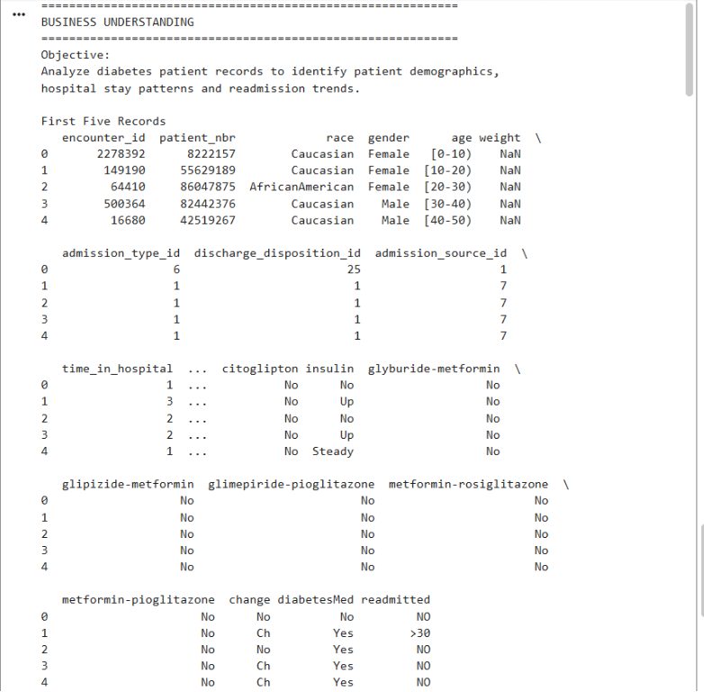
Output:

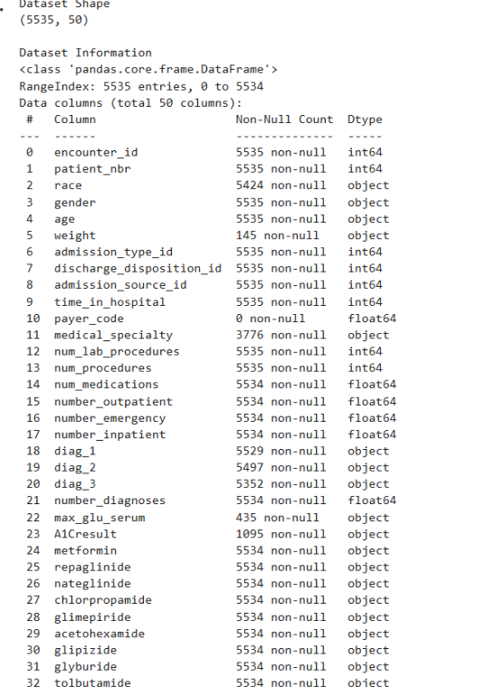

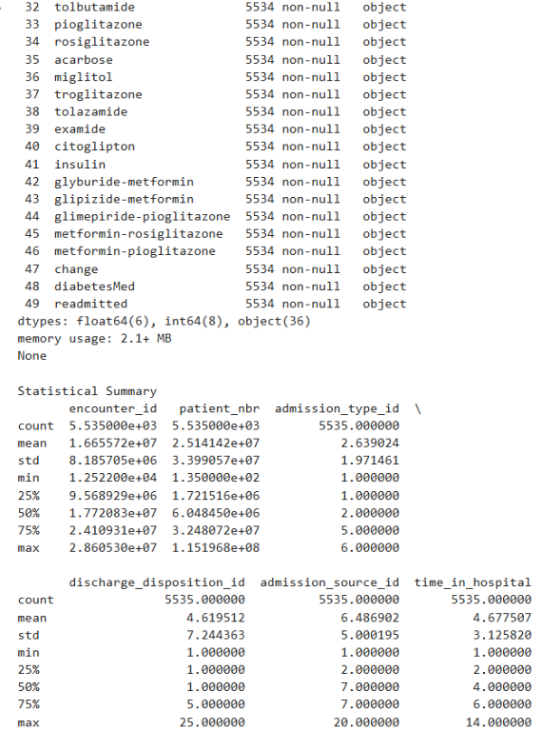

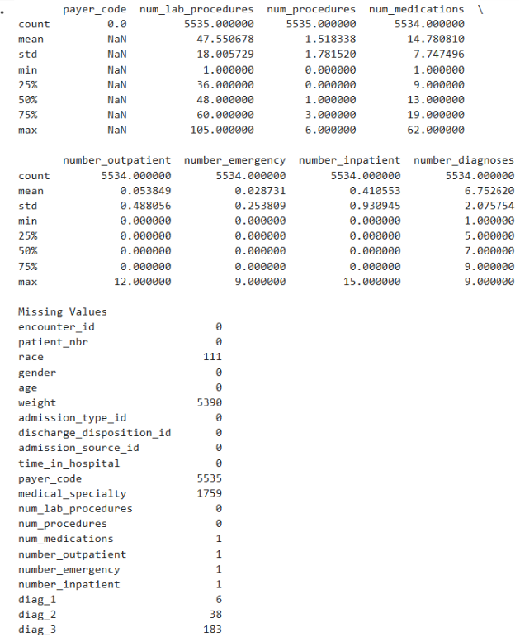

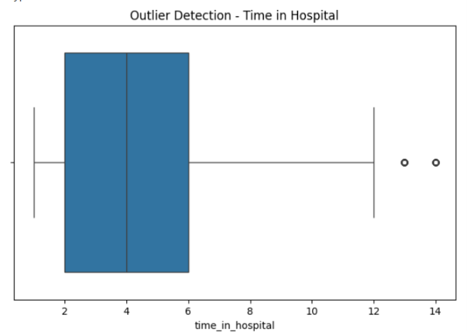

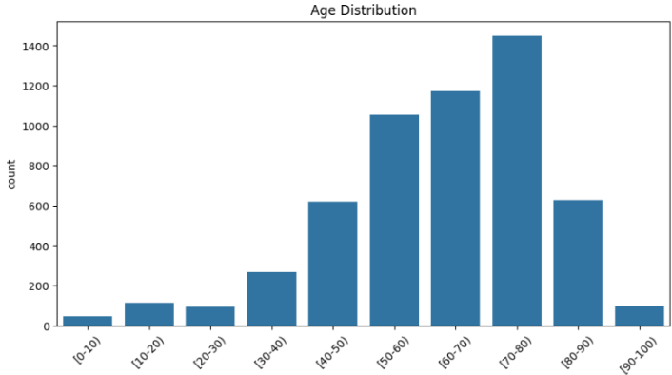

Result :

